**केन्द्रीय विद्यालय, पानागढ़ / KENDRIYA VIDYALAYA, PANAGARH**

**REGISTRATION NOTICE FOR ADMISSION IN CLASS-XI (2022-23) FOR NON K V, STUDENTS**

**DATED:-25/07/2022**

The non KV students who have passed AISSE-2022 from other schools may register for the admission in class - XI Science, Commerce & Arts for the session 2022-23, in the prescribed Registration Form & Option Form which is given here for downloading and also will be available in the Vidyalaya in all working days from 9 am to 1 pm till 02-08-2022.

All the candidates are requested to download the Registration Form & Option Form from here and submit the filled form by hand in the Kendriya Vidyalaya, Panagarh on or before 02-08-2022 between 9 am to 1 pm, along with a copy of their MARKSHEET, downloaded from the CBSE Website.

**The last date for the registration for the admission in class - XI is 02-08-2022.**

The non KV students may get admission only if the vacancy exists after accommodating the students of KV, Panagarh. For further details about admission procedure please refer KVS Admission Guidelines 2022-23 and our website https://panagarh.kvs.ac.in/school-announcement. The selected students will be informed through telephone and the website of KV Panagarh.

**प्राचार्य / PRINCIPAL**

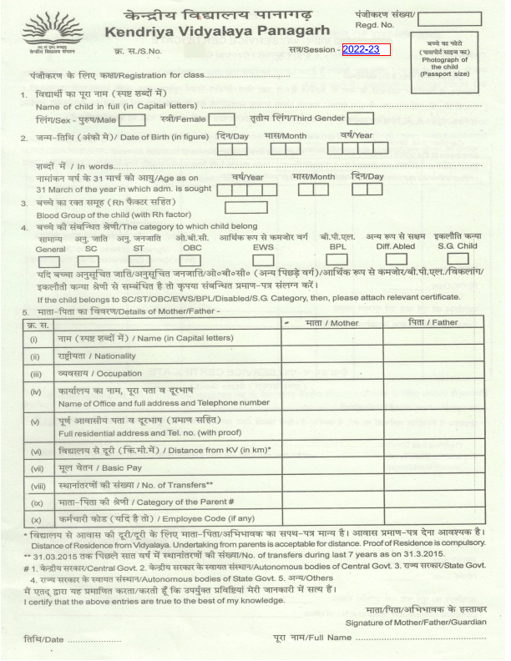

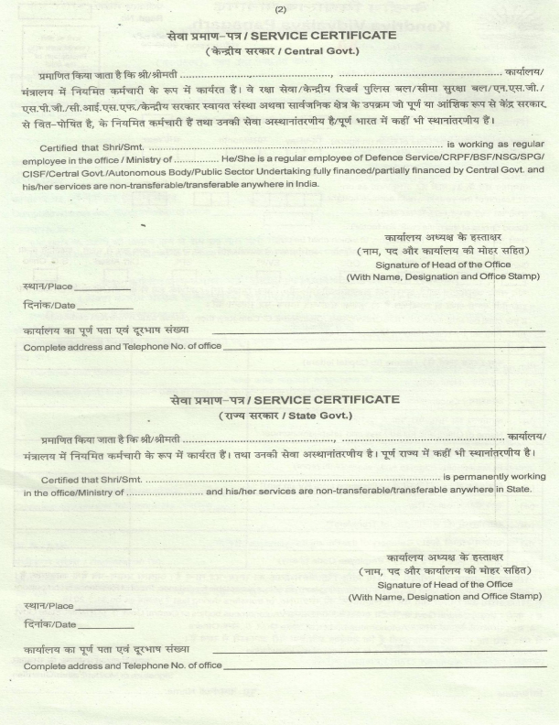

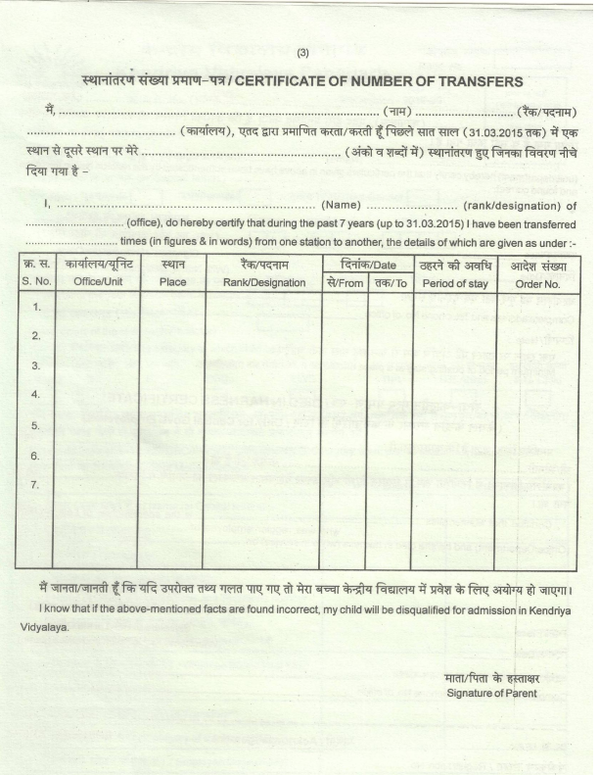

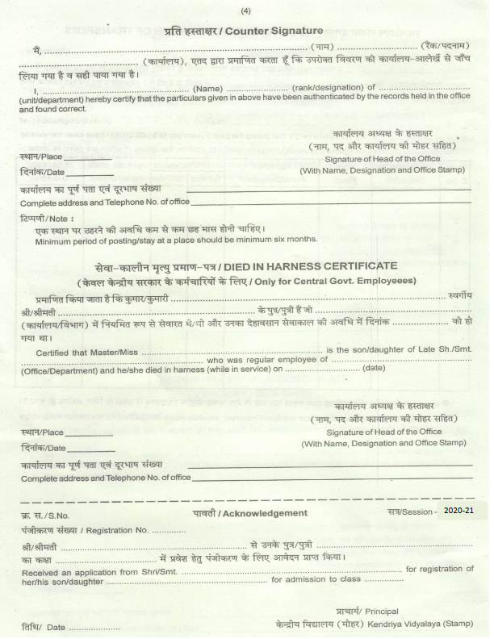

**KENDRIYA VIDYALAYA PANAGARH**

**REGISTRATION/OPTION FORM FOR ADMISSION IN CLASS-XI (SCIENCE/COMMERCE/HUMANITIES) 2021-22**

Admission No. for **KV PANAGARH** Students:___________ Section of Class X : ______

1.Name :____________________________________

PHOTO

2.Mother’s Name :____________________________________

3.Father’s Name :____________________________________

4.Adress with Telephone no. :____________________________________

____________________________________

Contact No. 1_______________________ (2)________________________

5.**Details of Marks/obtained in AISSE 2021 or Equivalent(Attach attested copy of Marksheet**).

|  |  |  |  |  |  |  |
| --- | --- | --- | --- | --- | --- | --- |
| **Subject** | **Max.**  **Marks** | **Marks obtained** | **Total Percentage (%)** | **Name of the Vidyalaya passing class-X** | **Name of Board** | **Year of passing class-X**  **ELEGIBILITY :-**  **(i) Science Stream:** A minimum of 60% Marks in aggregate of all subjects. **(ii) Commerce Stream:** A minimum of 55% Marks in aggregate of all subjects. **(iii) Humanities(Arts) Stream**: All students of KV if declared successful in class X exam. |
| **English** |  |  |  |  |  |  |
| **Hindi** |  |  |  |
| **Maths Standard** |  |  |  |
| **Maths Basic** |  |  |  |
| **Sc. With Pract** |  |  |  |
| **Social Sc.** |  |  |  |
|  |  |  |  |
| **Total** |  |  |  |  |  |  |

6.Marks out of **500** __________ **AND** overall percentage :_______________

7.Whether SC/ST/PH(Attach attested copy of Certificate) :________________

8.**Participation in Games & Sports:(Certificate should be attached)**

(i) SGFI / State Level / District Level :________________

(ii)KVS National / KVS Regional :________________

9.**N.C.C and Adventure Activities:- (Certificate should be attached)**

(i) “A” Certificate & participation on Republic Day / P.M.Rally/ Best cadet in Dist./State Level:________________

13. **Scouting/Guiding: (Certificate should be attached)**

(i) Rashtrapati Award Certificate :________________

(ii)Rajya Puraskar Award with 07 proficiency badges: :________________

(iii)Tritiya Sopan Certificate with 05 proficiency badges: :________________

14. **Subject Combination:**

|  |  |  |
| --- | --- | --- |
| **FOR SCIENCE STREAM** | **FOR COMMERCE STREAM** | **FOR HUMANITIES STREAM** |
| **Compulsory Subjects →** English Core ,Physics, Chemistry | **Compulsory Subjects →** English Core ,Accountancy, B. Std, Eco | English, Hindi, History, Geography, Economics. |
| **Optional Subjects**→(Maths + Bio) **or** (Maths + Computer Sc.) **or** (Bio + Hindi)or (Maths + Hindi) | **Optional Subjects**→ Maths **or** IP or Hindi |

**SUBJECTS OPTED BY THE STUDENT** **-**

***I am opting the following subjects and I hereby declare that as per CBSE instructions, I will not request for the change of any of the subjects opted by me in classes XI & XII.***

1________________2.________________3_______________4______________5_____________

________________________ _________________________

Signature of parents Signature of Candidate

-----------------------------------------------------------------------

**FOR OFFICE USE**

Admission granted in Class XI Science / Arts / Commerce with above mentioned Subjects

Signature of I/C Admission Signature of The Principal